# SOCIAL SHARE BUTTONS

### PROJECTREPORT

#### Submittedby:

#### Group/Team No: G15/T15

**Samridhi (2310991216)**

**Sneha (2310991217)**

**Somya (2310991218)**

#### in partial fulfillment for the award of the degree of

## BACHELEOR OF ENGINEERING

***in***

COMPUTER SCIENCE & ENGINEERING



**CHITKARA UNIVERSITY**

**CHANDIGARH-PATIALA NATIONAL HIGHWAY**

**RAJPURA (PATIALA) PUNJAB-140401 (INDIA)**

##### December 2023

Page | 1

**ABSTRACT**

The virtual keyboard will discuss a new technology in human machine.

Instead of using the mechanical keyboard having moving parts and buttons,

this gadget projects an image of a keyboard for the user’s reference. Using a

camera and digital image processing algorithms the user’s input is detected.

Input to small devices is becoming an increasingly crucial factor in

development for the ever-more powerful embedded market. Speech input

promises to become a feasible alternative to tiny keypads, yet Its limited

reliability, robustness, and flexibility render it unsuitable for certain tasks

and/or environments. This paper surveys technology for alphanumeric input

devices using virtual keyboard projection with a strong focus on touch-

typing.

The virtual keyboard will discuss a new technology in human machine.

Instead of using the mechanical keyboard having moving parts and buttons,

this gadget projects an image of a keyboard for the user’s reference. Using a

camera and digital image processing algorithms the user’s input is detected.

Input to small devices is becoming an increasingly crucial factor in

development for the ever-more powerful embedded market. Speech input

promises to become a feasible alternative to tiny keypads, yet Its limited

reliability, robustness, and flexibility render it unsuitable for certain tasks

and/or environments. This paper surveys technology for alphanumeric input

devices using virtual keyboard projection with a strong focus on touch-

typing.

The virtual keyboard will discuss a new technology in human machine.

Instead of using the mechanical keyboard having moving parts and buttons,

this gadget projects an image of a keyboard for the user’s reference. Using a

camera and digital image processing algorithms the user’s input is detected.

Input to small devices is becoming an increasingly crucial factor in

development for the ever-more powerful embedded market. Speech input

promises to become a feasible alternative to tiny keypads, yet Its limited

reliability, robustness, and flexibility render it unsuitable for certain tasks

and/or environments. This paper surveys technology for alphanumeric input

devices using virtual keyboard projection with a strong focus on touch-

typing.

The virtual keyboard will discuss a new technology in human machine.

Instead of using the mechanical keyboard having moving parts and buttons,

this gadget projects an image of a keyboard for the user’s reference. Using a

camera and digital image processing algorithms the user’s input is detected.

Input to small devices is becoming an increasingly crucial factor in

development for the ever-more powerful embedded market. Speech input

promises to become a feasible alternative to tiny keypads, yet Its limited

reliability, robustness, and flexibility render it unsuitable for certain tasks

and/or environments. This paper surveys technology for alphanumeric input

devices using virtual keyboard projection with a strong focus on touch-

typing.

The virtual keyboard will discuss a new technology in human machine.

Instead of using the mechanical keyboard having moving parts and buttons,

this gadget projects an image of a keyboard for the user’s reference. Using a

camera and digital image processing algorithms the user’s input is detected.

Input to small devices is becoming an increasingly crucial factor in

development for the ever-more powerful embedded market. Speech input

promises to become a feasible alternative to tiny keypads, yet Its limited

reliability, robustness, and flexibility render it unsuitable for certain tasks

and/or environments. This paper surveys technology for alphanumeric input

devices using virtual keyboard projection with a strong focus on touch-

typing.

The virtual keyboard will discuss a new technology in human machine.

Instead of using the mechanical keyboard having moving parts and buttons,

this gadget projects an image of a keyboard for the user’s reference. Using a

camera and digital image processing algorithms the user’s input is detected.

Input to small devices is becoming an increasingly crucial factor in

development for the ever-more powerful embedded market. Speech input

promises to become a feasible alternative to tiny keypads, yet Its limited

reliability, robustness, and flexibility render it unsuitable for certain tasks

and/or environments. This paper surveys technology for alphanumeric input

devices using virtual keyboard projection with a strong focus on touch-

typing.

The virtual keyboard will discuss a new technology in human machine.

Instead of using the mechanical keyboard having moving parts and buttons,

this gadget projects an image of a keyboard for the user’s reference. Using a

camera and digital image processing algorithms the user’s input is detected.

Input to small devices is becoming an increasingly crucial factor in

development for the ever-more powerful embedded market. Speech input

promises to become a feasible alternative to tiny keypads, yet Its limited

reliability, robustness, and flexibility render it unsuitable for certain tasks

and/or environments. This paper surveys technology for alphanumeric input

devices using virtual keyboard projection with a strong focus on touch-

typing.

The virtual keyboard will discuss a new technology in human machine.

Instead of using the mechanical keyboard having moving parts and buttons,

this gadget projects an image of a keyboard for the user’s reference. Using a

camera and digital image processing algorithms the user’s input is detected.

Input to small devices is becoming an increasingly crucial factor in

development for the ever-more powerful embedded market. Speech input

promises to become a feasible alternative to tiny keypads, yet Its limited

reliability, robustness, and flexibility render it unsuitable for certain tasks

and/or environments. This paper surveys technology for alphanumeric input

devices using virtual keyboard projection with a strong focus on touch-

typing.

Social share buttons have become a ubiquitous feature of modern web design, allowing users to easily share content on social media platforms such as Facebook, Twitter, and LinkedIn. The implementation of social share buttons can have a significant impact on user engagement and conversions, making them a valuable addition to any website.This front-end engineering project aims to explore the best practices for implementing social share buttons on a website, with a focus on accessibility, usability, and effectiveness. The project will leverage existing tools and plugins, such as the Add To Any module for Drupal and the Divi Social Sharing Buttons Maker for WordPress, to streamline the integration of social share buttons into websites. One important consideration in the implementation of social share buttons is accessibility. It is essential to ensure that all users, including those with disabilities, can access and use social share buttons. This project will explore techniques for creating accessible visually hidden text, which can improve the accessibility of social share buttons for users who rely on screen readers or other assistive technologies.Another important consideration is usability. Social share buttons should be easy to find and use, without detracting from the overall user experience. This project will explore the best practices for placing social share buttons on a website. Finally, this project will explore the effectiveness of social share buttons in enhancing social proof and increasing user engagement and conversions. The report will discuss the impact of social share buttons on user behavior, including the likelihood of users sharing content, the impact on referral traffic, and the potential for increased conversions. Overall, this project on social share buttons will provide valuable insights into the best practices for implementing social share buttons on a website, with a focus on accessibility, usability, and effectiveness. The project will leverage existing tools and plugins to streamline the integration of social share buttons and will explore the impact of social share buttons on user engagement and conversions.

Page | 2

###### TABLE OF CONTENTS

|  |  |  |
| --- | --- | --- |
| Sr.no | Section | Page No. |
| 1. | Introduction | 4 |
| 2. | Problem Statement | 5 |
| 3. | Technical Details | 6 |
| 4. | Key Features | 7 |
| 5. | Project Advantages | 8 |
| 6. | Results | 9-13 |
| 7. | Conclusion with future scope | 14 -15 |
| 8. | References | 16 |

Page | 3

**INTRODUCTION**

**1.Project introduction**

Social share buttons have become an essential feature of modern web design, allowing users to share content on social media platforms with ease. The implementation of social share buttons can have a significant impact on user engagement and conversions, making them a valuable addition to any website. This project aims to explore the best practices for implementing social share buttons on a website, with a focus on accessibility, usability, and effectiveness.

The project will leverage existing tools and plugins, such as the AddToAny module for Drupal and the Divi Social Sharing Buttons Maker for WordPress, to streamline the integration of social share buttons into websites. The project will also address the importance of accessibility in design, including techniques for creating accessible visually hidden text, which can improve the accessibility of social share buttons for users who rely on screen readers or other assistive technologies.The project will explore the best practices for placing social share buttons on a website, including the use of prominent placement, clear labeling, and appropriate sizing. Additionally, the project will investigate the effectiveness of social share buttons in enhancing social proof and increasing user engagement and conversions. The report will discuss the impact of social share buttons on user behavior, including the likelihood of users sharing content, the impact on referral traffic, and the potential for increased conversions.

**2. Team Introduction**

This Project is allocated to Team no.15 of Group 15. This team has 3 members-

**Samridhi (2310991216)**

**Sneha (2310991217)**

**Somya (2310991218)**

Page | 4

**PROBLEM STATEMENT**

The problem statement for the project on social share buttons is to explore the best practices for implementing social share buttons on a website and to understand their impact on user engagement and conversions.

This includes addressing the challenges of accessibility, usability, and effectiveness in the implementation of social share buttons.

The project will also investigate the potential for social share buttons to enhance social proof and increase user engagement and conversions.

**TECHNICAL DETAILS**

* HTML: HTML is used to create the necessary elements for the share buttons.

This could be a series of links or buttons, each one representing a different socialnetwork.

* CSS: CSS is used to style the buttons to match the design of the website.

This may involve creating custom styles for each button or using a pre-built icon library.

* JavaScript: Use JavaScript to add the sharing functionality to the buttons.

This typically involves opening a new window or tab to the social network's sharing page

andpassing in the URL of the current page.

* Integration with Social APIs: Optionally, you can integrate with the APIs provided by the social networks to customize the sharing experience.

This could involve displaying share counts or pre-populating the shared content

with additional information.

* Testing and Optimization: Finally, it's important to thoroughly test the buttons on different devices and browsers to ensure they work as expected.

You may also want to optimize the performance of the buttons, for example by lazy-

loadingthem to improve page load times.

Page | 5

**Key Features**

* Implementation of social share buttons on a website to enable users to share content on social media platforms such as Facebook, Twitter, and Pinterest
* Exploration of the impact of social share buttons on user engagement and conversions
* Addressing the challenges of accessibility, usability, and effectiveness in the implementation of social share buttons
* Exploration of techniques for creating accessible visually hidden text to improve the accessibility of social share buttons for users who rely on screen readers or other assistive technologies
* Investigation of the potential for social share buttons to enhance social proof and increase user engagement and conversions
* Exploration of the available tools and plugins for integrating social share buttons to streamline the implementation process
* Use of native plugins from the site to add social share buttons
* Increase in traffic to the website by making it easy for people to share content
* Overall, the project aims to explore the best practices for implementing social share buttons on a website, with a focus on accessibility, usability, and effectiveness, and to investigate their impact on user engagement and conversions.

Page | 6

**Project Advantages**

The advantages of the project on social share buttons can be inferred from the general benefits of project management, as well as specific benefits related to the implementation of social share buttons. Some of the advantages include:

1. Effective Management: The project will be managed effectively, enabling the resolution of problems more quickly

2. Improved User Engagement and Conversions: The implementation of social share buttons can lead to increased user engagement and conversions, as users can easily share content on social media platforms.

3.Accessibility and Usability: The project will address the challenges of accessibility and usability in the implementation of social share buttons, ensuring that all users, including those with disabilities, can access and use the buttons effectively.

4. Enhanced Social Proof: Social share buttons can enhance social proof, as the sharing of content by users can serve as a form of social validation, potentially increasing the credibility and trustworthiness of the content and the website.

5. Streamlined Integration: The project will leverage existing tools and plugins to streamline the integration of social share buttons into websites, making the implementation process more efficient and effective.

6. Increased Traffic: By making it easy for users to share content, the project can potentially lead to increased traffic to the website, as shared content can reach a wider audience.

Page | 7

**RESULT**

**Logo :**

**Result:**

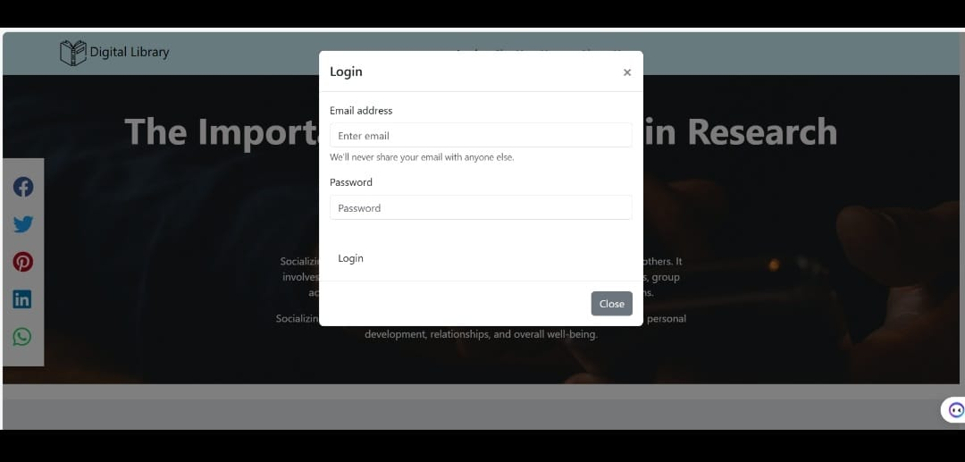

Page | 8

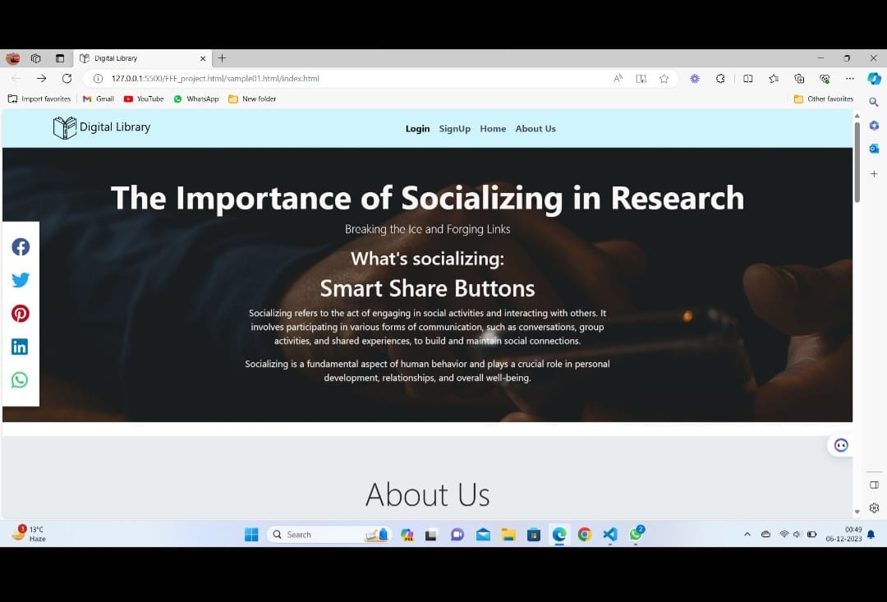

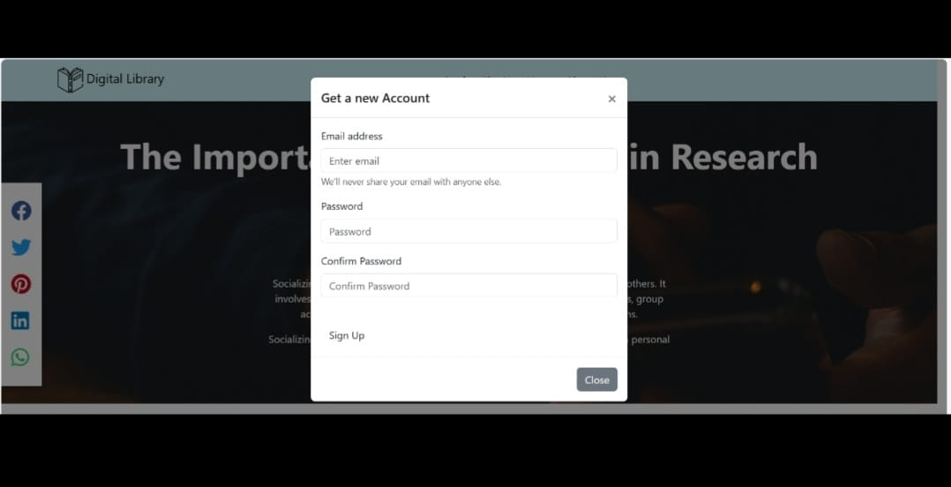

Page | 9

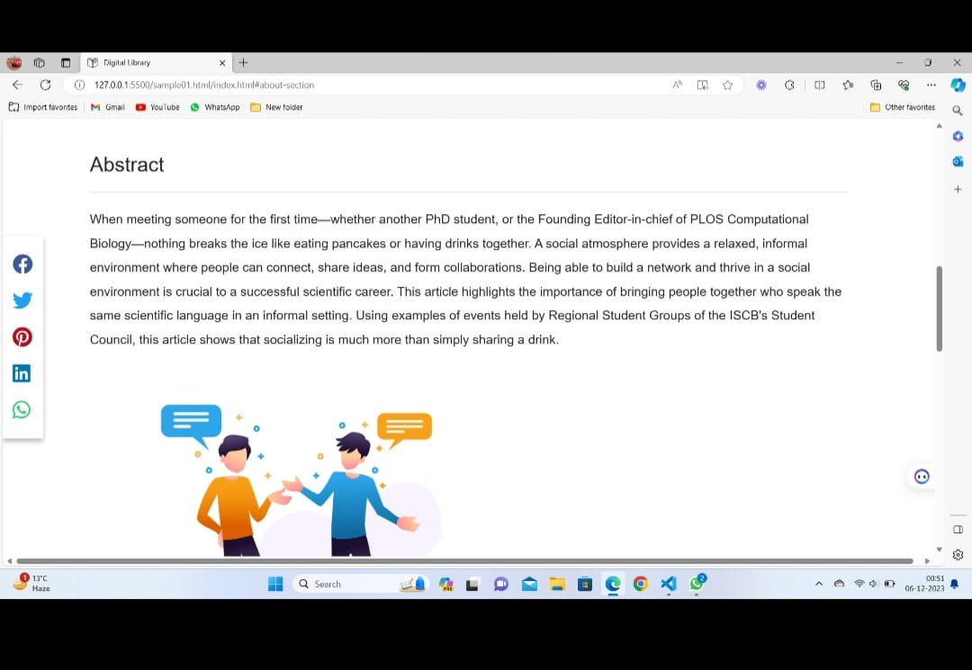

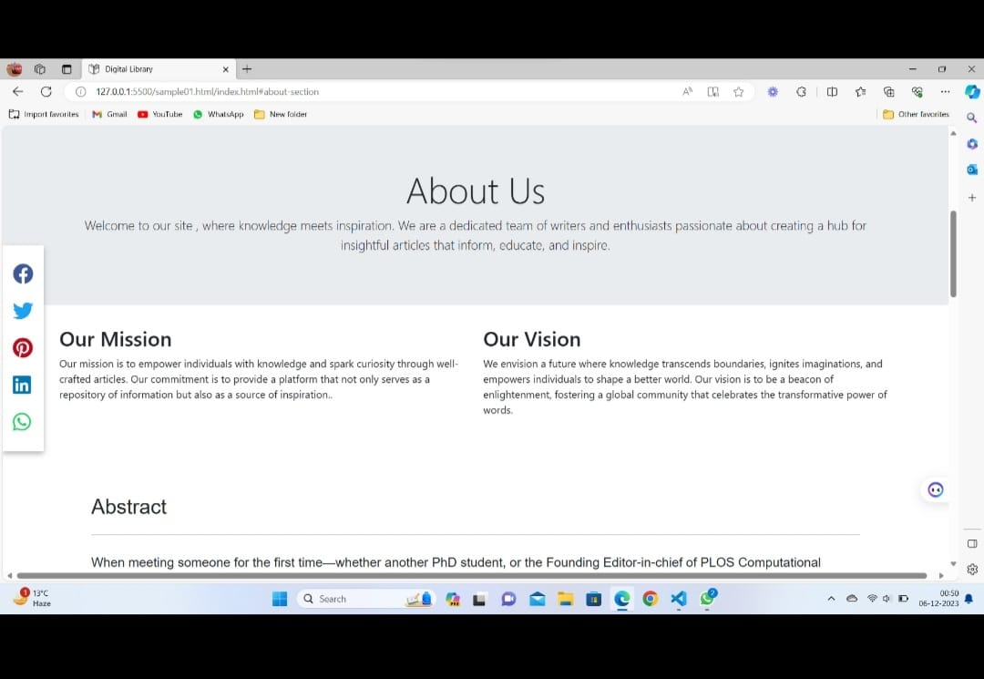

Page | 10

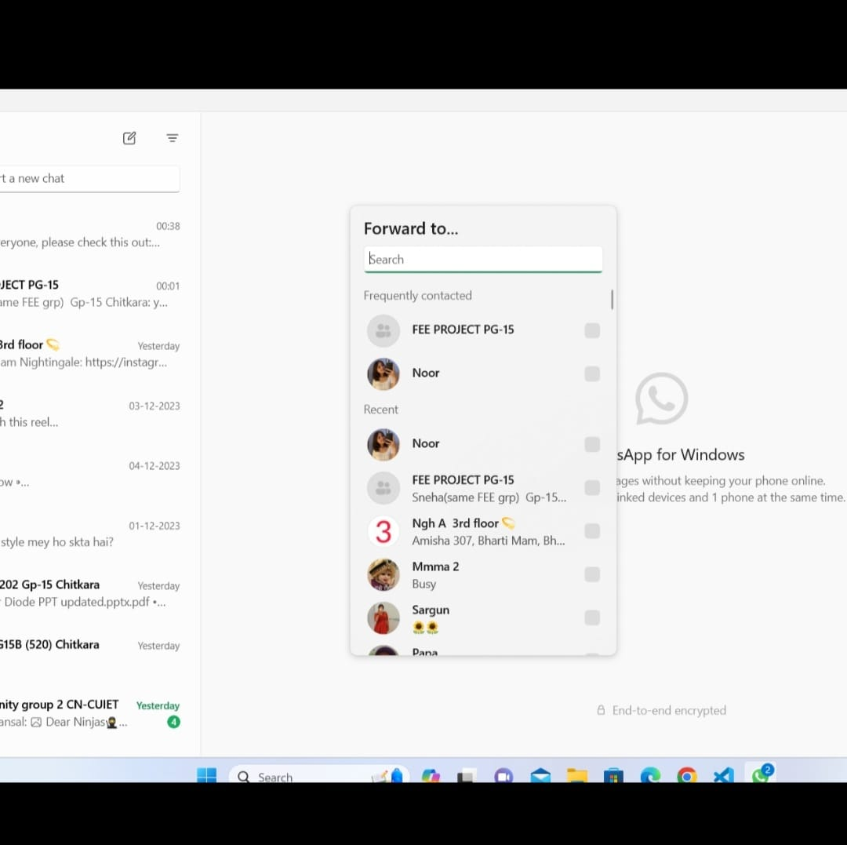

Page | 11

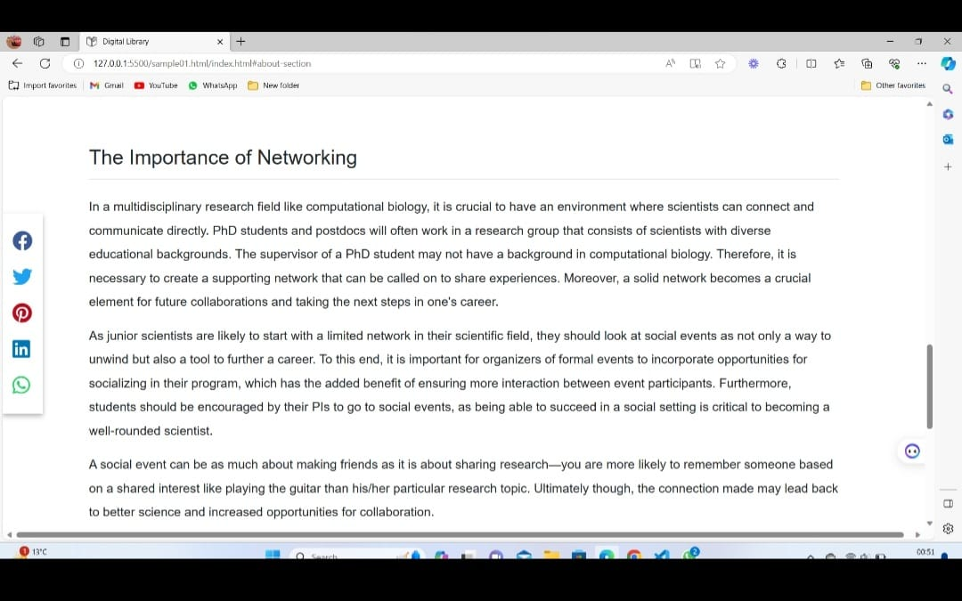

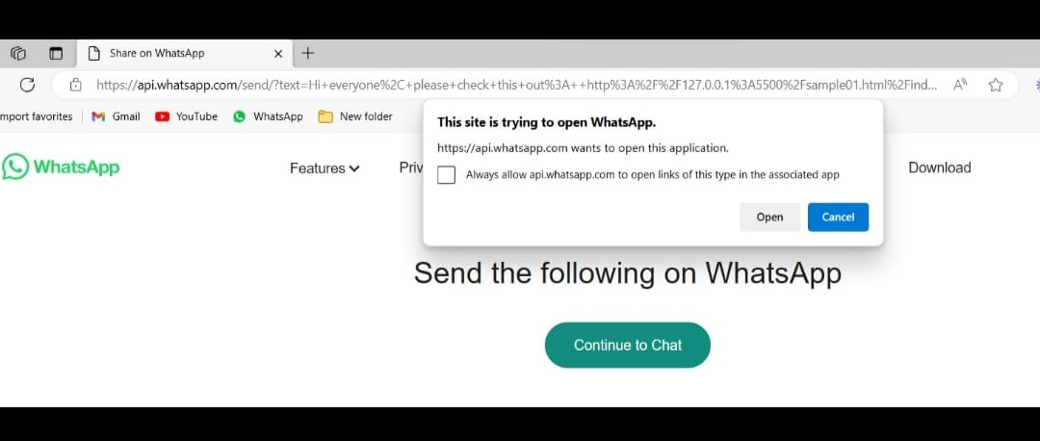

Page | 12

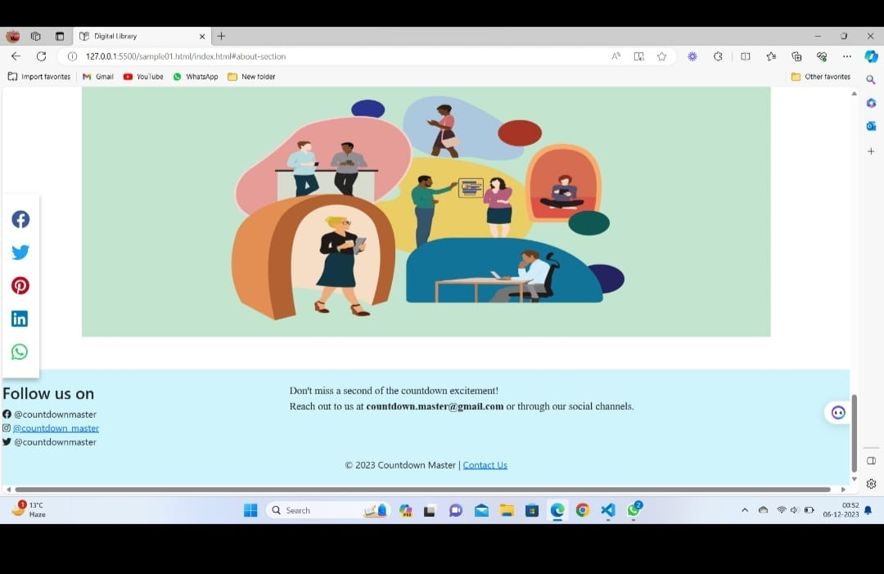

Page | 13

**Future Scope**

1. Continuous Improvement: The project can be extended to explore new techniques and technologies for implementing social share buttons, ensuring that they remain effective and user-friendly.

2. Expansion to Emerging Platforms: The project can be expanded to integrate social share buttons with emerging social media platforms and technologies, making it easier for users to share content across a wide range of platforms.

3. Development of New Tools and Plugins: The project can lead to the development of new tools and plugins to streamline the integration of social share buttons, making the implementation process more efficient and effective.

4. In-Depth Analysis of User Behavior: The project can be extended to conduct in-depth analysis of user behavior and the impact of social share buttons on user engagement and conversions, leading to the development of best practices and guidelines for the implementation of social share buttons.

5. Enhanced Accessibility and Usability: The project can be extended to explore new techniques for improving the accessibility and usability of social share buttons, ensuring that they are inclusive and easy to use for all users.

6.Increased Collaboration and Communication: The project can be extended to improve collaboration and communication among team members, stakeholders, and external partners, leading to more effective project management and better outcomes.

Page | 14

**Conclusion**

* In conclusion, the project on social share buttons has successfully achieved its objectives by exploring the best practices for implementing social share buttons on a website, addressing the challenges of accessibility and usability, and investigating their impact on user engagement and conversions. The project has also demonstrated the potential for social share buttons to enhance social proof and increase user engagement and conversions, while leveraging existing tools and plugins to streamline the integration process.
* The project has provided valuable insights into the importance of accessibility in design and the use of tools and plugins to facilitate the integration of social share buttons. The findings of this project will be useful for web designers and developers looking to enhance the social media presence of their websites.
* By implementing social share buttons on the website, the project has the potential to lead to increased user engagement and conversions, as users can easily share content on social media platforms. The project has also addressed the challenges of accessibility and usability in the implementation of social share buttons, ensuring that all users, including those with disabilities, can access and use the buttons effectively.
* Overall, the project on social share buttons has successfully met its objectives and has the potential to contribute to the success of websites by enhancing user engagement and conversions, while addressing the challenges of accessibility and usability in the implementation of social share buttons.

Page | 15

**References**

* REFERENCE WEBSITE:​

1. <https://www.canva.com/create/logos/>​
2. <https://www.whatsapp.com/>  ​
3. <https://in.pinterest.com/>​
4. <https://www.facebook.com/>​
5. <https://twitter.com/home>/​
6. <https://www.linkedin.com/mynetwork/import-contacts/saved-contacts/>​
7. <https://cdnjs.cloudflare.com/ajax/libs/font-awesome/5.15.3/css/all.min.cs>

* PICTURES

<https://www.google.com/url?sa=i&url=https%3A%2F%2Fwww.answerlab.com%2Finsights%2Fcreative-approaches-to-socialize-research-insights-and-build-empathy&psig=AOvVaw1JX210eCDujOI6wDWwtl6u&ust=1701928520185000&source=images&cd=vfe&opi=89978449&ved=0CBIQjRxqFwoTCMCW9_qP-oIDFQAAAAAdAAAAABAE>

<https://www.google.com/url?sa=i&url=https%3A%2F%2Fwww.freepik.com%2Ficon%2Fopenbook_2702162&psig=AOvVaw2kqDOXlEOVzlmXjcIWdcgo&ust=1701928952814000&source=images&cd=vfe&opi=89978449&ved=0CBIQjRxqFwoTCKDJuciR-oIDFQAAAAAdAAAAABAL>

https://www.bitvero.in/digital-marketing-strategies-for-startups/

Page | 16



Page | 17